**Functional Specification**

**FSD_FIN_I118- Z_FGL_WERCCA weekly concur ledger**

**Document Reference:**

**Version: 1.0**

**Document Status: Initial Draft**

**Author: Biprajit Mohapatra**

**Last Revision Date:**

**Date Created: 07-09-2021**

**Date Printed: <DD-MM-YYYY>**

**Document Information**

|  |  |
| --- | --- |
| **Business Area** | FIN |
| **FDD/ CR #** | I118 and I119 |
| **FS Definition ID** |  |
| **SAP Version** | S4 Hana 1909 |

**Approval**

|  |  |  |  |  |
| --- | --- | --- | --- | --- |
| **Approved by** | **Name** | **Role** | **Signature** | **Date** |
| Process Lead  Approval | Tom Z/Jason B |  |  |  |
| Legacy  Approval |  |  |  |  |
| Business Owner  Approval |  |  |  |  |
| Technical  Approval | Rajan Ray Chaudhury | Functional Lead |  |  |
| Development Team Lead | Roopa Prakash | Development Lead |  |  |

**Document History**

|  |  |  |
| --- | --- | --- |
| **Version** | **Reason for change** | **Date** |
| 1.0 | Initial Document | 07/09/2021 |

Table of Contents

1. General Information 4

2 Business Needs & Requirements 5

3 Assumptions 6

4 Objective 6

5 Functional Details 7

7 Custom Tables/Structure in SAP 13

8 Data Source consideration 13

8.1 Data Validation 14

9 Error Handling 14

10 Security Requirements/ Authorization Details 14

11 Testing Scenarios 14

# General Information

**PRIMARY RESPONSIBILITY: BP & SAP Functional**

|  |  |  |  |  |  |
| --- | --- | --- | --- | --- | --- |
| Area (SAP System components): | Accounting | | **Date:** | | 07/07/2020 |
| **Short description:** | Concur Weekly and Monthly Program Process | | | | |
| Requested by: |  | | **Tel no:** | |  |
| Author: | Biprajit Mohapatra | | **Tel no:** | | +91 9583409012 |
| **Program Transaction code:** | Custom | | | | |
| **Task ID/Demand Number:** |  | | | | |
| **Project Name:** | Project Simplify | | | | |
| **Priority:** | High/mandatory  Medium/recommended  Low/optional | | | | |
| **Complexity:** | High  Medium  Low | | | | |
| **Volume of data:** |  | Date available from: | |  | |
| **Mode:** | Online  Background | | | | |
| **Frequency:** | Daily  Weekly  Monthly  Biweekly  Others (Specify) : Whenever needed | | | | |
| **Technical information:**   1. **Type of Enhancement**   **2.Module /Submodule Information**  **3.Data Object (Purchase order/sales order etc.)**  **4. Dependency on any object** | UserExit  BADI  Requirement routine  Custom transaction  Business transaction event  Substitution & ValidationOthers  Enhancement Framework  Module       submodule | | | | |
| **General information:**   1. Results if no conversions are created: | Legal requirements not fulfilled  Lack of essential business information  Lack of functions compared to legacy system  Others (Specify): | | | | |

# Business Needs & Requirements

The existing process of Concur Weekly process to remain same for OFD and OFS except the RPA part which is going to be removed. The File will process all the correct records while sending a file consisting of error records to the SharePoint folder earlier accessed by Central Accounting Team.

There is no change in the format we are receiving the file. The external accounting ID remains the same distinguishing feature between OFS and OFD employees and accordingly the program should behave.

The entire OFD program FS is attached for reference at the end of this FS and is not included here as there is no change to the process flow of existing OFD and OFS program

The Monthly Process doesn’t flow thru RPA and is manually processed from Share point after ERRCA provides a file in the SP location

# Assumptions

# Objective /Requirements

# Functional Details

## 5.1 Current functionality

The Current functionality send the Weekly Expense report thru RPA Digital Worker. This happens every Tuesday.

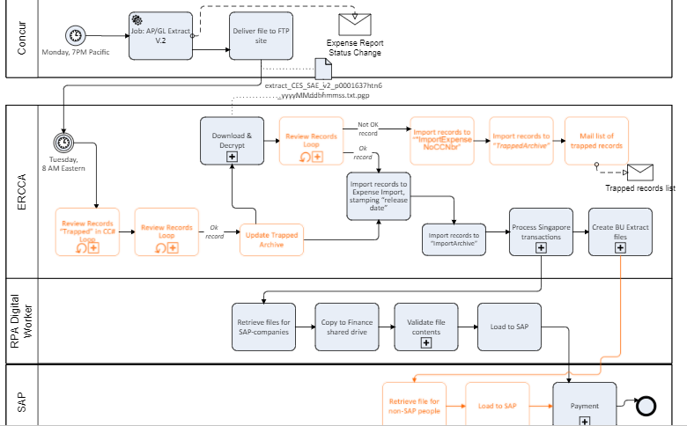

<Please ignore the light colour boxes this has nothing to do with change – this were in the original screenshot>

The monthly ERRCA program doesn’t go thru the RPA process and is extracted from SharePoint to be processed in WD+1; First day of the month .

## 5.2 Required functionality

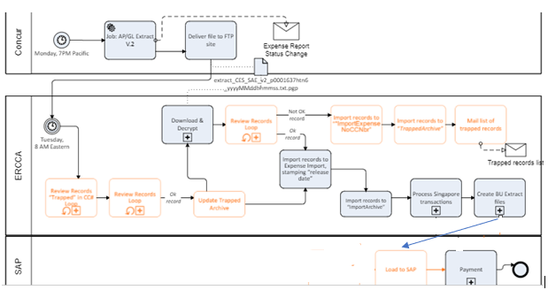

Going forward, we are removing the RPA from the flow. The Expense report out from ERRCA is directly consumed by SAP thru PI and Job process which will be an event based and is supposed to trigger once the File is in Application Folder.

The File is supposed to come thru PI to SAP and land in the below path or similar if the new path is required to be created in respective clients. Through event-based file triggering the Job triggers once the file is in the required folder

\\SAPPIF\INT\PE1\100\RTR\IN\S4_WeeklyConcur

\\SAPPIF\INT\PE1\100\RTR\ARCHIN\S4_WeeklyConcur

A copy of the file will be sent to ARCHIN to SAP functional team to look in case of any support issues.

Also, the program needs to come up with separate Tabs with errors and should have a downloadable excel button. In Realtime Prod, the data in this tab needs to be sent to the SharePoint address mentioned

Developer can refer the existing program for Bank Accounting to leverage and send the data outside SAP to SharePoint

ZWO_656526_2011A_FISERV (to send files from SAP to SharePoint)

The existing table maintenance of ZGGD_GEN_XREF needs to be updated with New Identifier values used in the Concur program

Going forward, there won’t be manual upload of Monthly Accrual reports as the Monthly accrual files will be pulled/pushed to SAP application folder. A similar event-based Job will trigger which will auto post the accrual entries. The frequency of the job start/trigger date is first day of the month.

\\SAPPIF\INT\PE1\100\RTR\IN\S4_MonthlyConcur

\\SAPPIF\INT\PE1\100\RTR\ARCHIN\S4_MonthlyConcur

The monthly program needs to be changed to capture the error entries in a separate tab, downloadable excel button and needs to send Share Point location shared.

In other words, Central Accounting Team should be able to access the complete error records info as was sent from ERRCA in SharePoint.

Relevant Identifiers needs to be updated in S4 System as this is used by the program. This includes Employee Vendor for the Cards used, the Profit center and IO used by India Company Codes (These changes from 2130 to 22XX)

Sample screenshot below of QE1 – ECC system

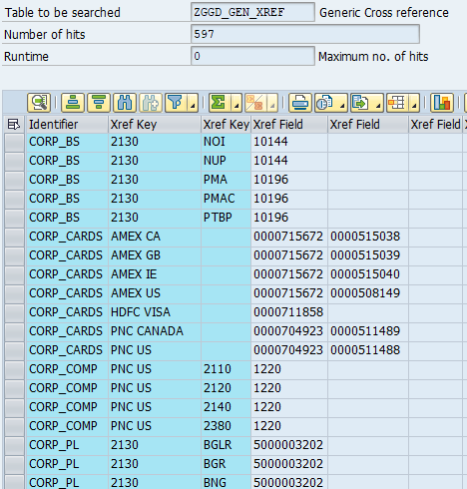

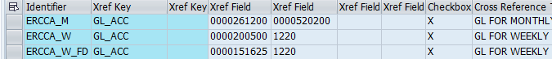

# Custom Tables/Structure in SAP

# Data Source consideration

# Data Validation

Please provide the data validation rules

**PRIMARY RESPONSIBILITY: BP & SAP Functional**

|  |  |
| --- | --- |
| **Table Field Name** | **Validation Rule** |
|  |  |
|  |  |
|  |  |
|  |  |
|  |  |
|  |  |
|  |  |

# Error Handling

# Security Requirements/ Authorization Details

Please describe any specific security requirements

**PRIMARY RESPONSIBILITY: BP & SAP Functional**

Business Function Role “BU Financial Analyst” will have access to new transaction code xxx to load the manual revenue repost file.

**PRIMARY RESPONSIBILITY: BP & SAP Functional**

|  |  |
| --- | --- |
| Normal Functionality - test cases that ensure the enhancement functions as it should. | |
| ID | Description |
|  | Test the Weekly and Monthly load in application folder |
|  | Test the Excel functionality |
|  | Test the files sending process from SAP to Sharepoint |

